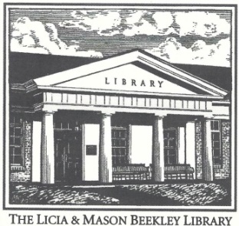
Licia & Mason Beekley Community Library
10 Central Ave. New Hartford, CT 06057
staff@beekleylibrary.org
860-379-7235

Electronic Device Lending Policy – Chromebooks

1.) Chromebooks may be borrowed by residents 18 years and older with Beekley Library cards in good standing that
can verify their identity with a valid photo ID. Our lending agreement must be filled out and signed.

2.) Chromebooks may be reserved. If there are no pending reservations, one renewal is permitted.

3.) One Chromebook may be borrowed per household at one time.

4.) The Chromebook kit includes: (1) Lenovo Chromebook 300e 2nd Gen, (2) 2 part Charging Cable, (3) Zipper Case.

6.) The loan period is fourteen (14) days.

7.) Chromebooks must be returned in person to the Beekley Library only.

7.) Patrons are encouraged to wait until the Chromebook kit is checked in by a staff member at the Circulation Desk. To ensure the safety of the equipment - DO NOT return the Chromebook and accessories in the book drop or to another library. Doing so will be treated as an instance of a late return and may result in billable device damage.

8.) Fines for overdue Chromebooks are $5.00 per day, not counting the days the library is closed. An “on-time” return is defined as a Chromebook that is returned to a library staff member prior to closing on the due date.

9.) Patrons shall not alter the Chromebook in any way, including (but not limited to) altering the settings of the device, adding programs to the device, or placing stickers or markings on the device, etc. The Library is not responsible for any liability, damages or expenses resulting from the use or misuse of a borrowed device, connection of the device to other electronic devices, or data loss resulting from use of the device.

10.) Any use of a Chromebook for illegal purposes, unauthorized copying of copyright-protected material in any form, or transmission of threatening, harassing, defamatory or obscene materials is strictly prohibited.

11.) Patrons will immediately report any hardware or software problems to Library staff.

12.) The patron is responsible for damage to or loss of the Chromebook or accessories as a result of accident, theft, misuse or neglect. Lost or damaged Chromebooks and/or accessories will be charged up to the full replacement cost of $180.00. Library staff will assess each device upon return and, if necessary, charge the patron accordingly – Chromebook - $150, 2 part Charging Cable - $15, Zipper Case - $15.

13.) IMPORTANT - Files cannot be permanently saved to Chromebooks – all files are erased when the user logs off. Borrowers are responsible for saving files in an alternate way (i.e. cloud storage or USB drive).

