How to sign into the Bibliomation Libby Collection

Until recently, the Licia & Mason Beekley Community Library was a stand-alone library and accessed their Overdrive/Libby digital collection through LCI (Library Connection Inc.) Our contract ended on December 31, when our Overdrive collection was switched over to our new consortium Bibliomation. All Overdrive and Libby services are now accessed through Bibliomation.

Here are the steps New Hartford residents need to take to access the Libby Collection in Bibliomation. If you are from another town that had access through the Beekley Library, please contact Library Director Jeanette Francini at 860-379-7235 or jfrancini@beekleylibrary.org

If you do not already use Libby or have the Libby App installed, go to the catalog page on our website:
https://www.beekleylibrary.org/catalog.html

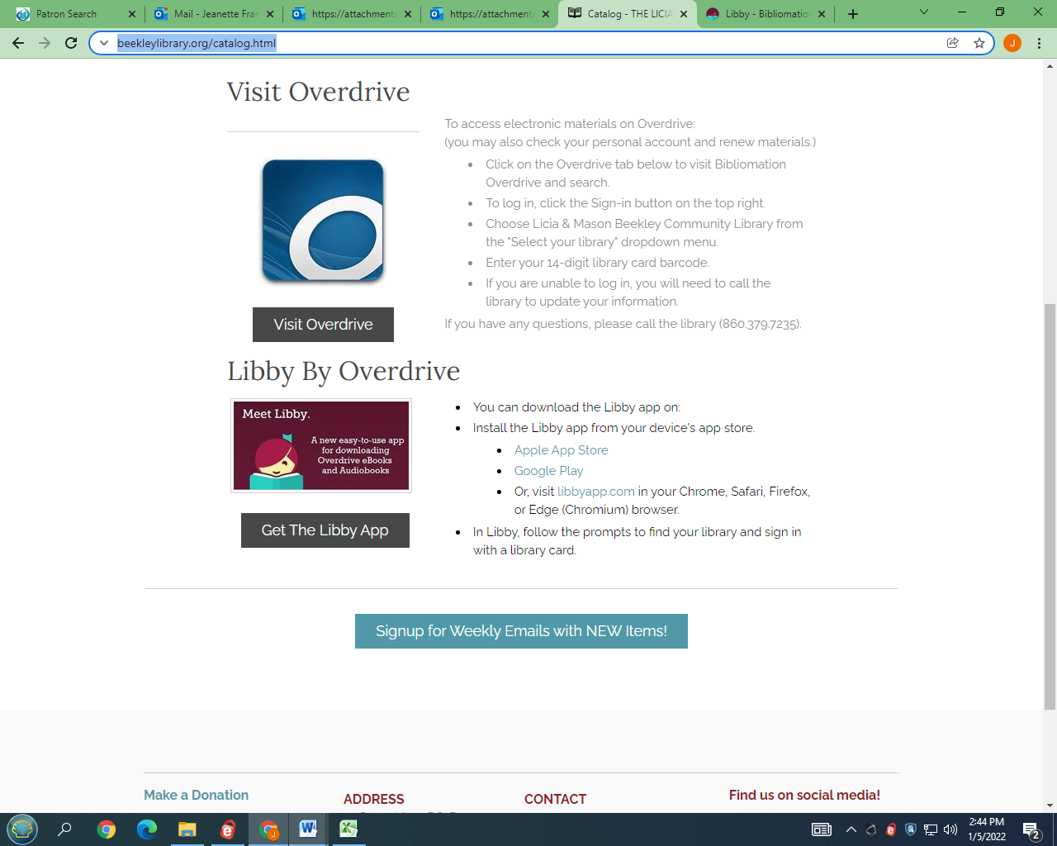

Click on the “Get The Libby App” button under the Libby logo –
or you can download the app from your device’s app store –
or use it in your browser from here
Get the app today! Or, use it in your web browser at libbyapp.com

If you already have an account on Libby, you will have to change it over to the Bibliomation collection by re-entering or changing your information. Fortunately, it's easier than you think! Follow the picture directions below.

To begin, open your Libby app and tap the 3-line icon in the middle of the bottom.

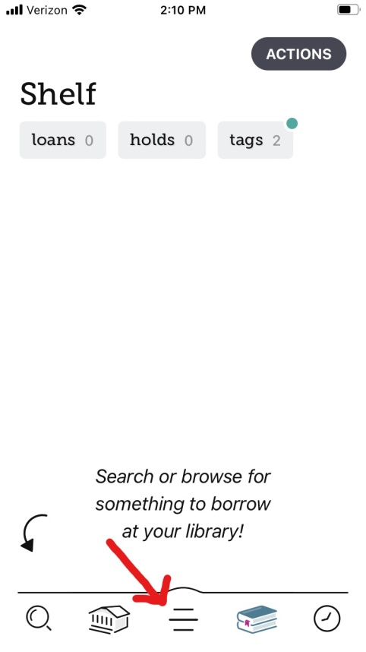

At the bottom of the screen, tap Add Library.

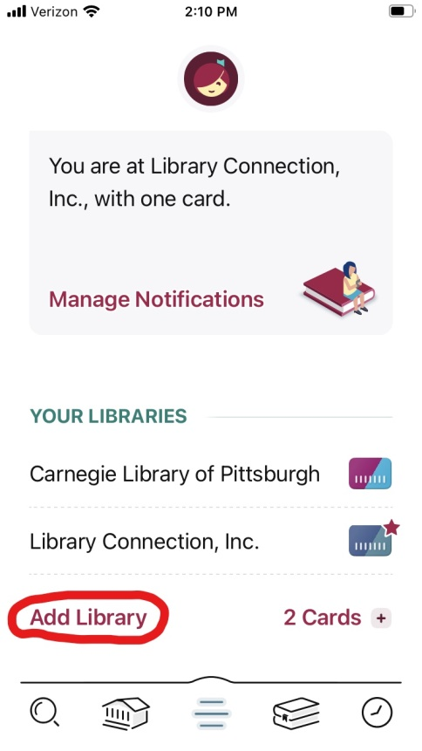

Next, in the box that says Library Name, you must enter Beekley.
It may offer you a Library Connection version of the Beekley, but you need the Bibliomation Beekley, which will only appear if you enter the name "Beekley" into the box.

Tap the Bibliomation Beekley.

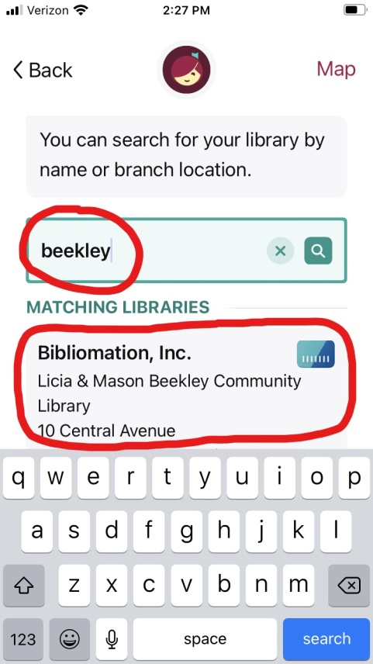

Next, tap Sign In With My Card.

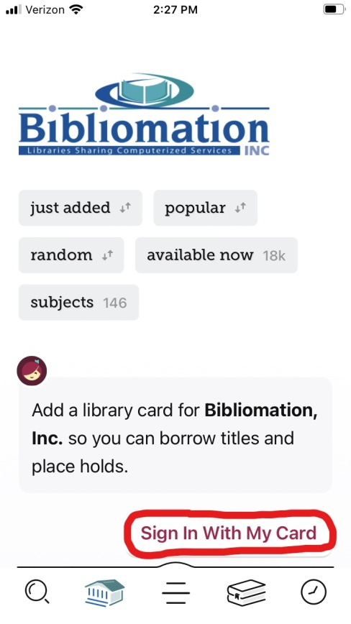

Tap Licia & Mason Beekley Community Library.

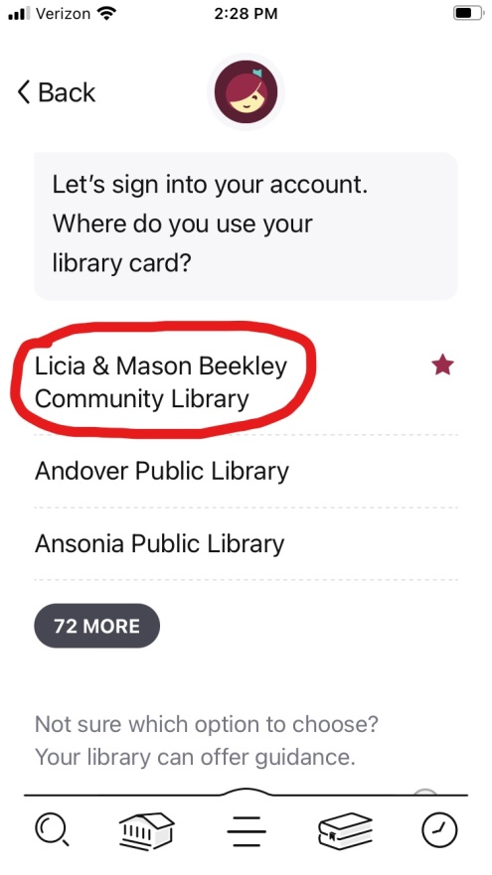

Then enter your full 14-digit library card number and tap Sign In.

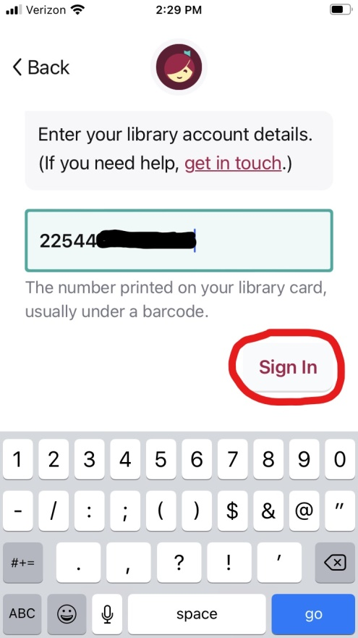

Tap Next, and you are ready to use your new Bibliomation Libby account.

